**Lecture 25**

**Sudoers-UMASK**

Sudo will be useful in future at the time of work in industry **InnSha Allah**



Suppose user wants to give a user privilege to start and stop apache web server.

* $ visudo **is useful because it checks for any syntax errors 🡪** but $ vi /etc/sudoers can’t check for errors and simply edits the file 🡪 **basically it starts in debugging mode.**
* 
* The user will be able to access only the commands which are added din sudoer file
* It would be hectic task to assign a user multiple commands and type it again and agqin,
* The solution is templets in sudoers file,
* ***How to create template?*** 
  + 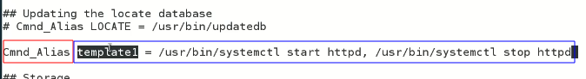
  + Just type template name ,
  + 
* **To make a user as “root” 🡪 interview question** 
* 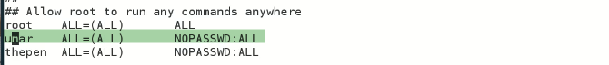
* Just copy above line and change the work root with the specific user_name
* **Remember: -** 
  + **Who is an Admin in Linux?**
  + **Root is not an Admin 🡪 root is a super user.**
  + **In Linux the user that have UID 0 is an Admin.**
  + **Root is just a name**
  + 
  + **Kernel always look for UID and 0 UID means super user**
* 
* Another way is to edit “etc/passwd” file and change UID to 0 GID to 0
* Text

  Description automatically generated
* How it works?
* ***Kernel looks for UID, if it is 0 it means that is a super user.***

**PATH**

* 
* The paths of these two commands with “which” command is,
* 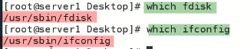
* So,
* When we check the paths with **$ echo $PATH**
* The system lists the paths.
* The “root” can run these commands because their pats are listed or associated with root.
* For example a command is “firework” and its path is in /opt 🡪 it will not run because its path is not set.
* Because /opt path is not set,
* 
* When we type “fd” and press TAB TAB
* 
* The system shows the options 🡪 it is because its path is set
* If move a command our of the path, it will not work,
* 
* **As we moved “fdisk” to /opt 🡪 the fdisk command will not work anymore.**
* Now “which” command will show this message
* 
* No fdisk in 7 paths …
* So in future if a command doesn’t work,
  + Solution
  + Find it 🡪 $ find / iname fdisk
  + Here the command will work if its absolute path will be given
  + $ /opt/fdisk -l
* So how to set path?
* **$ PATH=$PATH:/opt** 🡪 now /opt path is included
* 
* This path is not persisted.
* To persist 🡪 add the same command in booting file/ etc/profile
* **The paths are user specific.**

**UMASK**

* Usermask
* The user file-creation mode mask (umask) is used to determine the file permission for newly created files. It can be used to control the **default file permission for new files**.
* **umask** is a command-line utility in Unix and Unix-like operating systems that stands for "user file creation mode mask". It is used to set the default file permission mode for newly created files and directories.
* The **umask** value is a 3-digit octal number that represents the permissions that should be removed from the default file permission mode. The default permission mode is 666 for files and 777 for directories. The value of **umask** is subtracted from the default mode to determine the actual permission mode for the newly created file or directory.
* For example, if the **umask** value is 022, then the write permission is removed from group and other users. So, the actual permission mode for a newly created file will be 644 (666 - 022), which means that the owner has read and write permissions, and group and other users have read permission only.
* To check the current **umask** value, you can use the **umask** command without any arguments. To set a new **umask** value, you can use the **umask** command followed by the new value in octal notation. For example, to set a **umask** value of 027, you can use the following command:
* **umask 027**
* 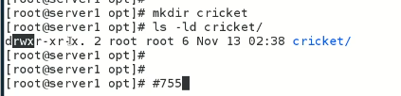
* The cricket directory has 755 permission by default.
* 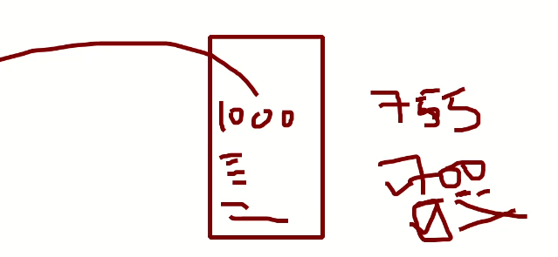
* If a server is being accessed and users are creating 1000 directories
* These directories have permission 755 which is not ideal
* We want to set the permission to 700 -🡪 this is called “umask”
* To set default the permissions over directories and files is called **umask.**
* 
* The values of umask can be changed
* $ umask <value> 🡪 $ umask 0077
* 
* **Now the by default permissions of the directory is changed.**
* To persist umaks,
* Add it in /etc/bashrc file
* Umask 0077
* 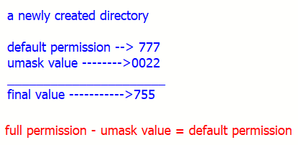
* Foe file
* **The permission of file is purposely set to 666 instead of 777 for security reasons**
* So,
* Text

  Description automatically generated with medium confidence
* 